**Glasgow’s Learning for Sustainability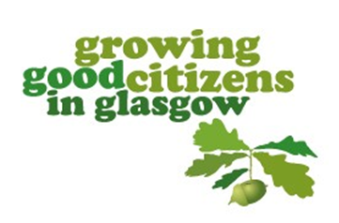Learning for Sustainability in Glasgow**

**What is learning for sustainability?**

**Learning for sustainability (LfS) is an approach to life and learning which enables learners, educators, schools and their wider communities to build a socially-just, sustainable and equitable society. An effective whole school and community approach to LfS weaves together global citizenship, sustainable development education and outdoor learning to create coherent, rewarding and transformative learning experiences. (Education Scotland)**

**Young people need to experience the outdoors to appreciate our natural world and understand interdependence and see the benefits to our health and well-being. They need to develop as global citizens, understanding the world they live in and how their actions and decisions impact on themselves, others and the world around them. They need to understand the importance of sustainability, what we need to do to ensure that this planet can sustain all life and how people can make changes both in their own lives but also how they can affect decisions made locally, nationally and globally.**

**Glasgow schools and early years’ establishments want to build on the experiences, knowledge and skills gained at home and in their local community.**

**Learning for a Better World**

**Glasgow’s Vision:**

**To support all children and young people to be caring, responsible and active global citizens developing the skills, knowledge and attitudes they need as adults to enjoy living in harmony with others, in a just and sustainable world.**

**All children and young people in Scotland have an entitlement to Learning for Sustainability and it is the responsibility of all practitioners to ensure this happens. This is a whole school approach.**

**How will Glasgow continue to support establishments?**

**3 year action plan in place in line with the Scottish Government’s Vision2030+ Action Plan.**

**Access to professional learning opportunities for staff in all establishments.**

**Sharing of good practice across the city.**

**Easily accessible information for practitioners, to support learning and teaching through an updated website.**

**Working with partners to provide further support, training and resources.**

**Supporting pupil voice.**

**At Garrowhill Primary School/Early Years Establishment we provide Learning for Sustainability opportunities for all our young people through:**

**Learning opportunities through Interdisciplinary Learning**

**Outdoor learning opportunities (including educational visits)**

**Partner working with organisations from the community**

**School Parliament and House Meetings**

**Growing Glasgow (planting seasonal fruit/vegetables)**

**Supporting local and international charity appeals across the year**