
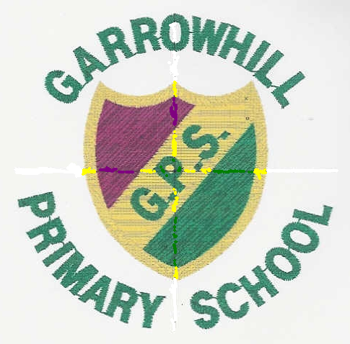
GARROWHILL PRIMARY
NEWSLETTER

E-mail contact: headteacher@garrowhill-pri.glasgow.sch.uk

www.garrowhill-pri.glasgow.sch.uk
Dear Parents/Carers,
Welcome to our January school Newsletter. I wish you all a happy, healthy and successful year in 2010!
WHOLE SCHOOL INFORMATION
Pupil Attendance at School

I am disappointed to report that our school attendance figure has dropped to its lowest ever level to 88.62% I cannot emphasise enough the importance of regular attendance at school. Frequent absence disrupts learning and prevents children from achieving their full potential. I hope that we can work together to improve this figure over the coming term.
P1 | P2 | P3 | P4 | P5 | P6 | P7
95.83% | 88.33% | 91.50% | 82.81% | 89.02% | 87.69% | 87.67%

CAR PARKING AROUND GARROWHILL PRIMARY SCHOOL
In recent days, I have been very disappointed to hear reports of some our parents driving dangerously on the pavements in order to pass other cars on roads around the school. This selfish and reckless driving is potentially endangering the lives of others.
As adults, we are role models for our children and it is vital that safe and responsible driving practices are modelled at all times. Please show greater concern and consideration for all when dropping off or collecting children.

NURSERY PROPOSAL
The application for planning permission to build a nursery on the land formerly used for our external annexes is ongoing. I will keep you updated with further developments.
LOST PROPERTY
We have a large amount of unclaimed clothing and shoes in our lost property area. I would be grateful if you could NAME all your children’s belongings.
CONFIDENT INDIVIDUALS
Well done to Miss Russell’s children in Primary 3 who were effective contributors at our two Christmas Services in Mure Memorial Church where they successfully performed a Nativity play.
Christmas Performance at RSAMD
Last term a group of P7 pupils successfully performed with ‘Little Larks’.
EFFECTIVE CONTRIBUTORS
A group of 30 Primary 6/7 pupils attended Scottish Ballet’s production of ‘The Nutcracker’ at the Theatre Royal. The children had attended a workshop related to the production earlier in the term.
ACTIVE CITIZENSHIP
Our Pupil Council representatives raised £286 for the Prince and Princess of Wales Trust.
Christmas Carol Singing
At the St. Enoch’s Centre, our Junior Music Group raised a generous sum of money for Ronald Macdonald House, a charity set up for parents of children who are terminally ill.
Primary 7 Choir
Our P7 carol singers raised £121.26 for Shelter Scotland one chilly afternoon at the Fort. This was supplemented with £219.96 from the offering collected at our Christmas Services making a total of £341.22 raised for Shelter Scotland.

P4 Christmas Carols
Our Primary 4 pupils visited 2 local homes for the elderly and sang a medley of Christmas Carols. The children were a credit to our school and both performances were greatly enjoyed by all the elderly citizens in Garrowhill.
Garrowhill Recycles
As part of our eco schools work, we recycle a number of items at Garrowhill:
Paper, plastic bottles, printer ink cartridges, mobile phones and old clothing are items you may wish to contribute to our recycling efforts. We are also encouraging children to bring in Christmas cards this month and support the Woodland Trust’s campaign to recycle cards and plant more trees.
SUCCESSFUL LEARNERS
Christmas Art Competition
Well done to Eve Beattie P7B1 who won 1st prize in Bailie Macdonald’s Christmas card competition.
Medieval Glasgow
P6C visited Stirling Castle, Provand’s Lordship, the oldest house in Glasgow and Glasgow Cathedral to enhance their learning about life in medieval times.
Victorian Class
P6H visited Scotland Street School to experience a lesson in a Victorian classroom. At the end of term the children organised a successful ‘Dickens Day’ where they all dressed up in Victorian costume and lived a day in the life of a Victorian child at Garrowhill Primary.
PARTNERSHIP WITH PARENTS
We will hold an Extraordinary General Meeting (E.G.M.) for the Fundraising Committee on Wednesday 27th January 7-8.00 pm. We are looking for new parents to volunteer.
One key task will be to elect a new Chair and Vice Chair for the Committee, as well as progress other plans for the remainder of the session.

DATES OF INTEREST:
- Burns Night 6.30-8.30pm:Tuesday 26th January 2010-Poetry recitations and songs performed by Garrowhill Primary School pupils P3-P7. All parents/carers are warmly invited to attend.
- UNICEF DAY FOR CHANGE: Friday 5th February. This is a fundraising day when the children are invited to take part by dressing up in a fun way.



- The Rocky Horror Monster School Show performed by P6/P7 pupils: provisional dates for the performance at Mure Memorial Church, 7.15-8.30pm Tuesday 9th and Wednesday 10th February. Further details will be issued shortly.
- INSET day: Friday 12th February. Children do not attend school on these staff training days.
- Mid-term holiday Monday 15th-Tuesday 16th February
- INSET day 4: Wednesday 17th February.
- School Book Fair Week (provisional): Monday 1st-Friday 5th March.
- Parents’ Meetings to discuss children’s progress: Tuesday 9th March, 3.30-6.30pm & Thursday 18th March, 4.30-7.30pm.
- School Healthy Lifestyles Week: Friday 26th March-Thursday 1st April.
- Spring Break: Friday 2 April to Friday 16 April 2010 (inclusive).
Yours sincerely,

Richard DC Buchan
Headteacher.



