Monday  Health Team / Judo | Health team  9.05-9.30 P3 room 10 10.50-11.15 P4 room 8  9.30-10.00 P3 room 11 11.20-11.45 P5 room 9  10.00-10.30 P4/3 room 7 11.50-12.15 P5 room 17 | Judo  9.30-10.00 P1’s 1.15-1.45 P5’s  10.00-10.30 P2’s 1.45-2.15 P6’s  11.00-11.30 P3’s  11.30-12.00 P4’s inc P4/3
Tuesday  Massage/ peek a boo play | Massage  9.00-9.30 Room 1 11.00-11.30 Room 4 1.10- 1.40 Room 10  9.30-10.00 Room 2 11.30-12.00 Room 5 1.40-2.10 Room 11  10.00-10.30 Room 3 2.10-2.40 Room 7  Peek a boo play in lower stages playground @ lunchtime
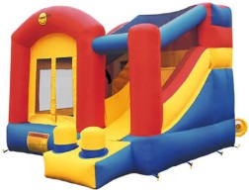  Wednesday  Bouncy Castle | Small Castle Drama Studio  9.30-10.00 Room 1 1.15-1.45 Room 5  10.00-10.30 Room 2 1.45-2.15 Room 10  11.00-11.30 Room 3 2.15-2.45 Room 11  11.30-12.00 Room 4 | Large Castle outside (hopefully)  9.30-10.00 Room 7 1.00-1.30 Room 16  10.00-10.30 Room 8 1.30-2.00 Room 15  11.00-11.30 Room 9 2.00-2.30 Room 14  11.30-12.00 Room 17 2.30-3.00 Room 13
Thursday  Massage/ peek a boo play | 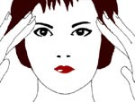  Massage  9.00-9.45 Room 17 1.05-1.40 Room 15  9.45-10.30 Room 8 1.40-2.15 Room 14  10.45-11.30 Room 9 2.15-2.55 Room 13  11.30-12.15 Room 16  Peek a boo play in senior playground @ lunchtime
Friday  Sports | Kenny and Coaches  9.30-10.00 P1’s 1.15-1.45 P5’s  10.00-10.30 P2’s 1.45-2.15 P6’s  11.00-11.30 P3’s 2.15-2.45 P7’s  11.30-12.00 P4’s inc P4/3

