The Raven Returns
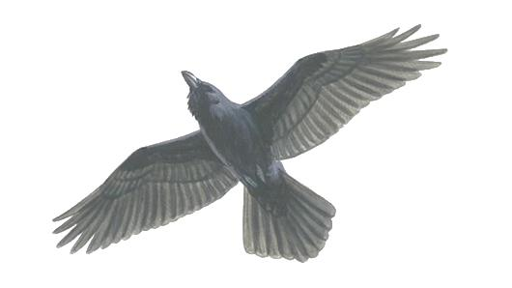
As I glided through the air, I saw my reflection in the deep blue sea. I wondered what it would be like to reach land. The Vikings were close behind.
I arrived on land. I perched myself on top of a tree and watched the chaos down below. Crimson-red blood splattered everywhere when the unstoppable Eric the Bloodaxe pierced his axe through the heart of an Englishman.
Monks rang the bell ferociously, but it was too late, nearly everyone was killed or taken to be a slave. I preened my feathers and prepared to fly back to Odin.

