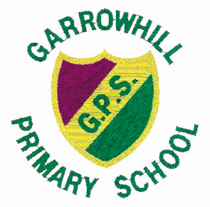

SP0NSORED ZUMBA
FRIDAY 7TH OCTOBER, 2016

Please help us raise funds for Garrowhill Primary School

NAME OF SPONSOR | DONATION
TOTAL AMOUNT COLLECTED | £



