
Garrowhill Primary School:
Digital Learning Strategy

INTRODUCTION

This generation of children has come into a world in which digital technology is abundant. Their world is a world of technology which they start interfacing with from a very young age.

It is important that we ensure that all pupils in our school are equipped with the skills they might require to adapt to an ever-changing technological landscape. In Garrowhill Primary, we encourage the use of digital learning as a means of supplementing and enhancing the learning and teaching experience. The children are presented with a wide range of opportunities and experiences to ensure they can successfully utilise their digital skills and knowledge in a variety of contexts.

BACKGROUND

The Scottish Government recently launched a digital learning and teaching strategy for Scotland, Enhancing Learning and Teaching through the use of Digital Technology.
Glasgow City Council’s response has three work-streams:

- Digital Leadership and Culture
- Digital Services
- Digital Foundations

It is aligned with the national strategy with its education aims and priorities:

- Raising attainment and achievement
- Enhancing the leadership of staff
- Supporting families to be better able to support their children’s learning and development
- Make best use of resources

OUR VISION

At Garrowhill Primary, we will ensure a curriculum that prepares our children and young people for the social and economic impact of technology, supporting them as they develop the social, emotional and cognitive abilities that enable individuals to face the challenges and adapt to the demands of the digital world.

Staff, through their GTC Professional Standards, will demonstrate a critical understanding of digital technologies and how these can be used to support learning. Through self-evaluation and professional learning, staff will have increased confidence in the use of digital technology.

We will ensure that access for parents and carers to information on children and young people’s progress will be enhanced through digital technology. Engagement, collaboration and communication with parents and carers will increase, as will support for them in improving children and young people’s digital literacy and understanding of e-safety.

OUR DIGITAL LEARNERS

- We will ensure that our learners have quality learning experiences in which digital technologies can help support and enhance the learning taking place.
- Pupils will have access to new technology that reflects our ever changing and adapting digital society.
- Our learners will have access to online tools and resources that can help support their learning needs.
- We will provide our learners with the tools and knowledge to use technology safely and appropriately both at school and at home.
- Our learners will understand the risk associated with using technology and working online and will receive support in identifying and managing these risks.
- Our learners will have access to tools to create and share content with their peers, staff and parents.
- Our learners will be educated about how to evaluate materials found online and understand how to safely and legally use this material.
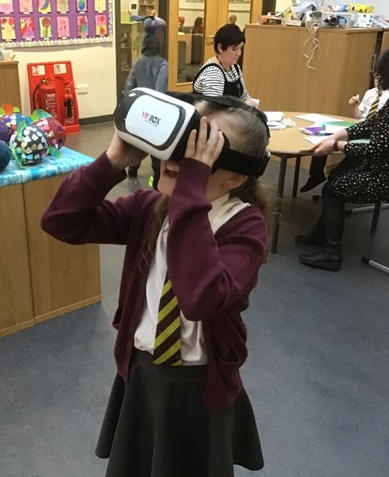
- We will support our learners to become responsible online citizens, ensuring they build positive relationships with their peers online.

OUR STAFF

- Our Digital Learning Strategy will be shared and supported by the Senior Management Team, Teaching Staff, Support for Learning Workers and all other stakeholders.
- Our member of staff who is named Digital Leader of Learning will continue to meet with and share updated information from GCC and CGI around digital learning in the city.
- All teachers will complete the Apple Teacher Training Programme led by the Digital Leader of Learning.
- In house training will be provided for all teachers by the Digital Leader of Learning and from staff wishing to share good practice.
- Modelled lessons and specialist visitors will help demonstrate the value of Digital Learning and allow teachers to share examples of good practice.
- Time will be allocated to the school’s working time agreement for digital training and evaluating digital experiences.
- Online safety training will be kept up to date to ensure our children are kept safe when using digital technology.

PARENTS, CARERS AND FAMILIES

- Digital technology will be used to increase parental engagement and build links between home and school using Twitter and Seesaw app.
- Seesaw app will be used to give regular updates on pupils progress through posts showing a child’s latest work and through comments shared with pupils and parents about next steps in learning.

- Parent workshops will be offered on aspects of digital learning including internet safety and being a responsible online citizen.

MANAGING TECHNOLOGY

- We will work closely with GCC and XMA to plan our roll out, scheduled for 2020, in line with local authority requirements.
- The member of staff fulfilling the Digital Leader of Learning role will be in charge of the digital resources and any issues should be reported to the correct team.
- Devices and data will be stored securely as per the council requirements.
- All staff trained annually on data security procedures.

FINANCIAL SUSTAINABILITY

- Pupil Equity Funds and other budgets will be used to purchase new technology.
- GCC and XMA will provide a managed service for devices in our roll out scheduled for 2020.
- Funds will be used to maintain technology including repairs.
- Funds will be used to purchase apps which will enhance pupils learning and experiences.

