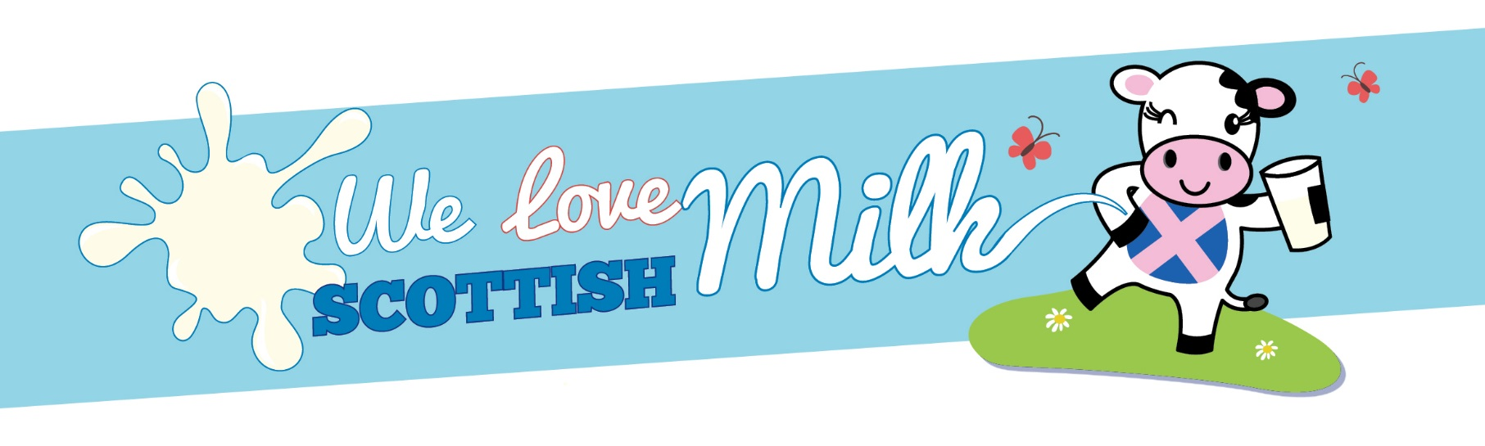
We Love Scottish Milk

In a bid to encourage primary school pupils to drink milk and further reduce the amount of sugar in our Fuel Zone menu (in line with the Scottish Government recommendation) Cordia will provide only plain milk in all primary school Fuel Zones from 15th August 2017. This promotion campaign is titled: ‘We Love Scottish Milk’.

Milk provides many nutrients which play an important role within the body throughout the different stages of life. In primary school children, milk continues to provide essential nutrients for growth and development, as well as helping to protect teeth.

Posters will be placed around the Fuel Zone highlighting key facts about milk and the benefits to the body. Pupils will receive a sticker when they opt for a carton of milk during their lunch break.

All pupils are entitled to a free carton of milk each day in the Fuel Zone regardless of whether they use the service for their lunch. So pupils who have packed lunch or go home for their lunch can still take a free carton of milk every day.

END

